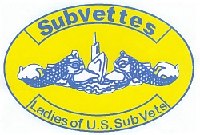
SUBVETTES MEMBERSHIP APPLICATION
LADIES OF U.S. SUBMARINE VETERANS of SAN DIEGO

Welcome to SUBVETTES, the Ladies of U.S. Submarine Veterans Organization. Annual base dues are payable upon joining, and on the first day of each year. (Applicants joining in November or December are paid thru the end of the following year.)

NAME____________________________________________TELEPHONE _________________
ADDRESS___________________________________________________________
CITY, STATE, ZIP______________________________________________________
DATE OF BIRTH ____________________________________ (must have reached 16th birthday)
E-MAIL ADDRESS____________________________________________________
SPONSOR’S NAME___________________________________________________
RELATIONSHIP TO SPONSOR __________________________________________

SIGNATURE________________________________
Base Annual Membership Dues are $12.00 per year. Please return application and check made payable to “SUBVETTES of SAN DIEGO” to the base Secretary listed on our web page at http://www.ussvisandiego.org/Subvettes.htm

